Preventing Errors Using Informatics
Name
Institution
Date

Preventing Errors Using Informatics
By Name
Quality and safety education for nursesensures nurses' training in using the required competencies to help improve the safety and quality of the healthcare systems. Informatics is one of the six competencies, ensuring the use of technology in communication, management of knowledge, reducing errors, and decision-making (Olds & Dolansky, 2017). Nurses use informatics systems to reduce medical errors while interacting with patients in the process of providing care. The advancement in technology has resulted in the implementation of informatics systems that are effective in helping various processes that are related to the process of providing care to patients. For example, the use of informatics system has enabled the improvement of the decision-making process in aiding in the coming up with the best diagnosis for the patient and the plan of care.
Research has supported the use of informatics systems in the reduction of medical errors. The medical errors include misdiagnosis, unnecessary treatment, medication mistakes, unnecessary tests and procedures, and uncoordinated care. The use of an informatics system has been found to be effective in minimizing medical errors. The informatics systems are fitted with software to help in the process of providing care (O'Connor& LaRue, 2021). With the informatics system, nurses can impute information about the patients in the system and store the information for future reference. The use of informatics system also ensures the coming up with the best decision concerning the patient's diagnosis and treatment by using the already used and effective diagnosis and treatment care plan for the patients. It is important to reduce the medical errors while taking care of patients and, therefore, the need to incorporate teaching on informatics to students.
The use of informatics systems requires having the skills and knowledge to operate the system. Nurses have to be trained in how to make effective use of the informatics systems and ensure the best results are acquired with informatics systems. There has been an incorporation of the teaching of informatics systems in the nursing curriculum to prepare nurses to make use of the informatics systems effectively to improve care and reduce medical errors. Due to the continuous development in technologies, the informatics systems undergo changes, and therefore healthcare institutions should ensure that the medical teams have up-to-date skills in the use of the systems (Alexandrova et.al, 2018). There have been programs and bodies that have been put in place to empower nursing informatics professionals. Some of the professional bodies include national nurses' week, an online journal of nursing informatics, and an alliance of nursing informatics. The bodies offered support for nurses as they navigate through the use of informatics.
The use of informatics systems has been effective in ensuring medical errors are reduced in an effort to increase the health outcomes for the patients.
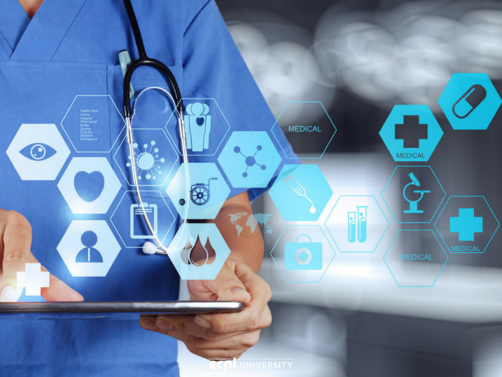

References
Alexandrova, E., Shapekova, N. L., Ak, B., Özcanaslan, F., & Efe, R. (2018). Health Sciences Research in The Globalizing World.
O'Connor, S., & LaRue, E. (2021). Integrating informatics into undergraduate nursing education: A case study using a spiral learning approach. Nurse Education in Practice, 50, 102934.
Olds, D., & Dolansky, M. A. (2017). Quality and Safety Research: Recommendations from the Quality and Safety Education for Nursing (QSEN) Institute. Applied nursing research: ANR, 35, 126-127.

